Text for social media posts – Pre-fieldwork
Social media card: Take action
Recently used NHS Community Mental Health services?
We are launching a survey in August to collect your valuable feedback. Your feedback will help us improve the quality of our care and people’s experience.
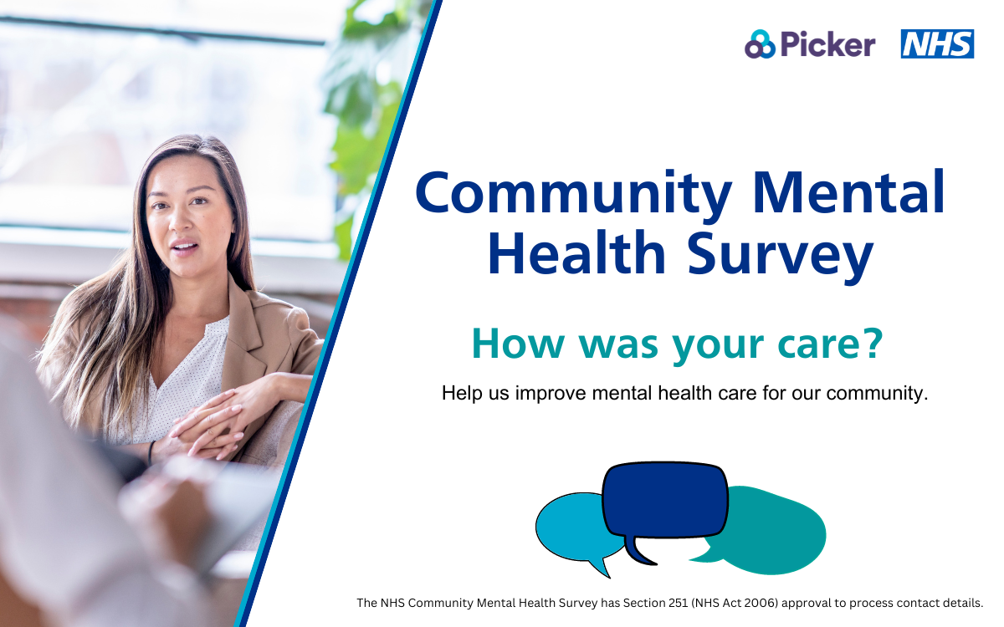

Social media card: Reminder One
We’d love to hear about your experiences. The best way for us to improve your care is by hearing from people who have recently used our services.
Please look out for the survey in the post during August 2025.
#CommunityMentalHealthSurvey
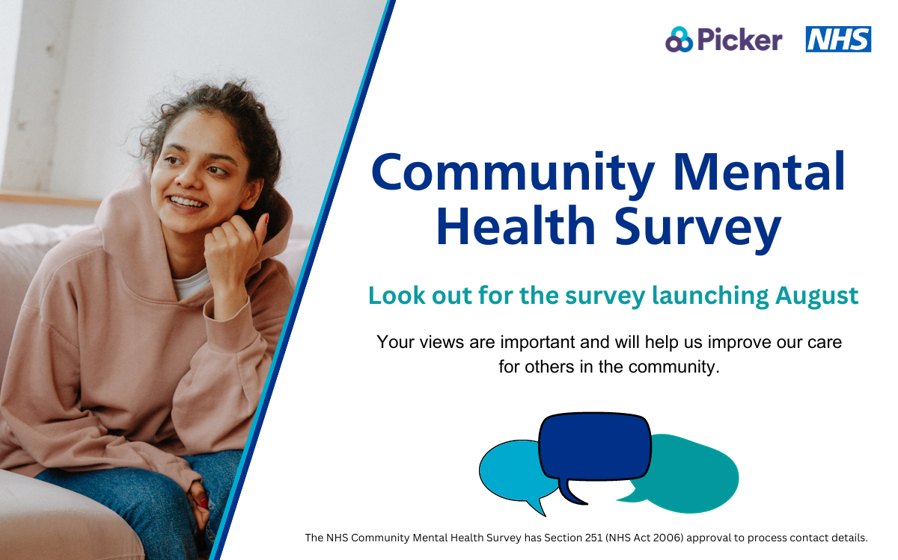

Social media card: Reminder Two
Will you take a moment to share your experience of mental health care? You may randomly be selected to take part in the 2025 #CommunityMentalHealthSurvey
Please take a moment to complete the survey and help us make a positive difference to our care and services.
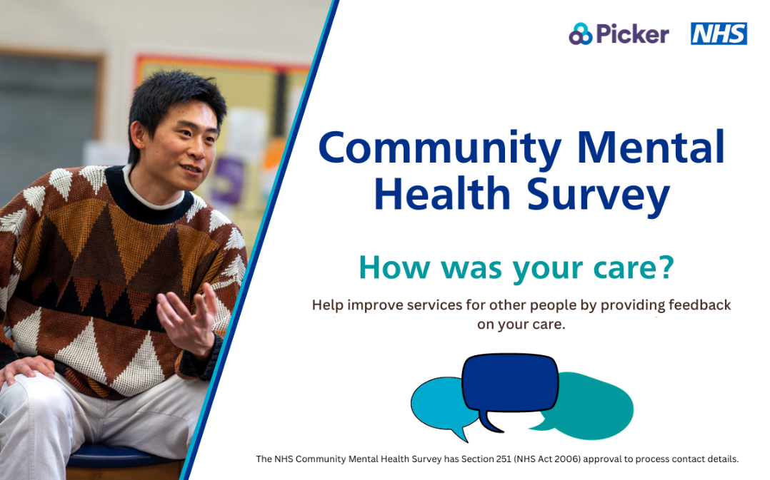

Social media card: Reminder Three
Have you used community mental health services in April and May 2025? In August we are launching a survey to collect your feedback on your NHS mental health care.
We are listening closely to what you have to say, your response will help us improve mental health care for you and our community.
#CommunityMentalHealthSurvey
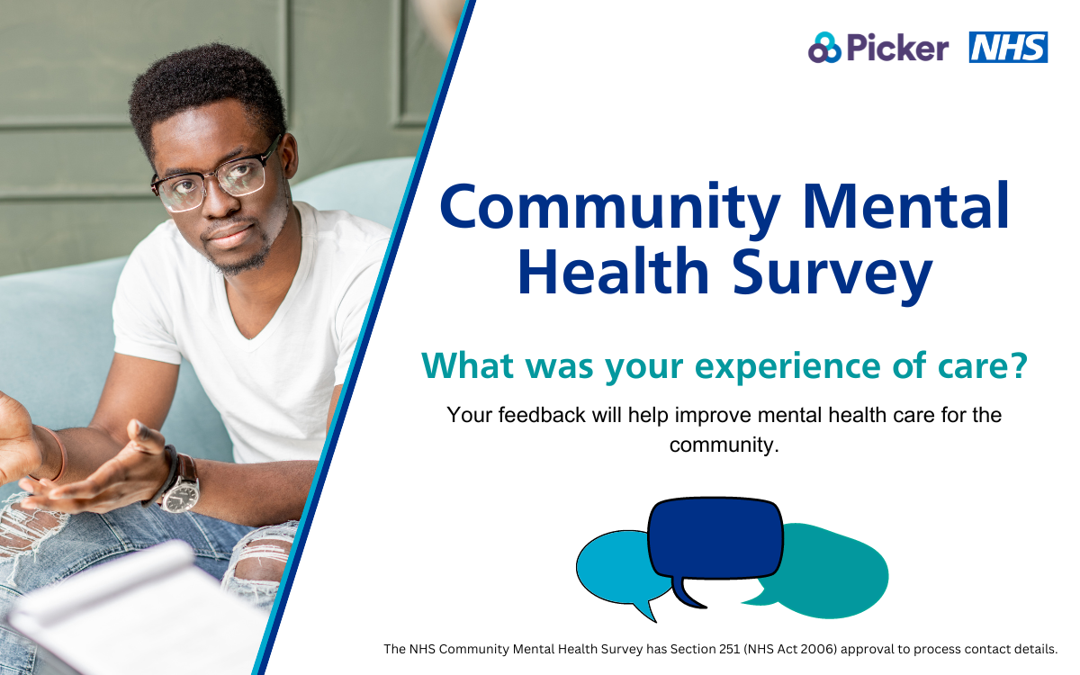
Text for social media posts – during fieldwork
Social media card: Take action
Recently used NHS Community Mental Health services?
Look out for the #CommunityMentalHealthSurvey arriving in the post soon. Your valuable feedback will help us improve the quality of our care and people’s experience.

Social media card: Reminder One
Take the opportunity to make a difference to NHS Community Mental Health care.
We’d love to hear about your experiences. The best way for us to improve your care is by hearing from people who have recently used our services
#CommunityMentalHealthSurvey
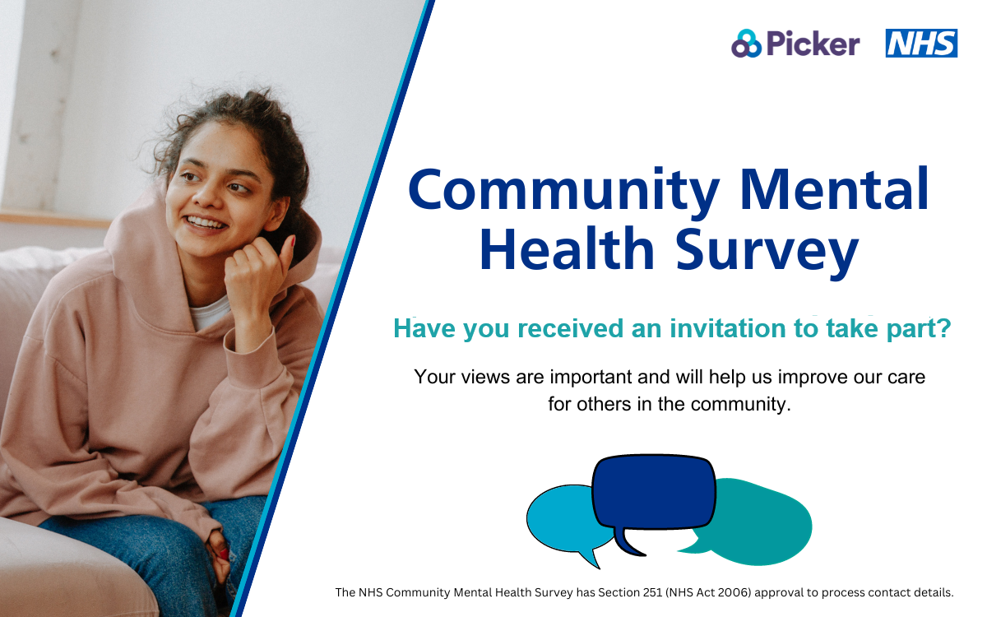
Social media card: Reminder Two
Will you take a moment to share your experience of mental health care? Look out for your #CommunityMentalHealthSurvey in the post!
Please take a moment to complete the survey and help us make a positive difference to our care and services.
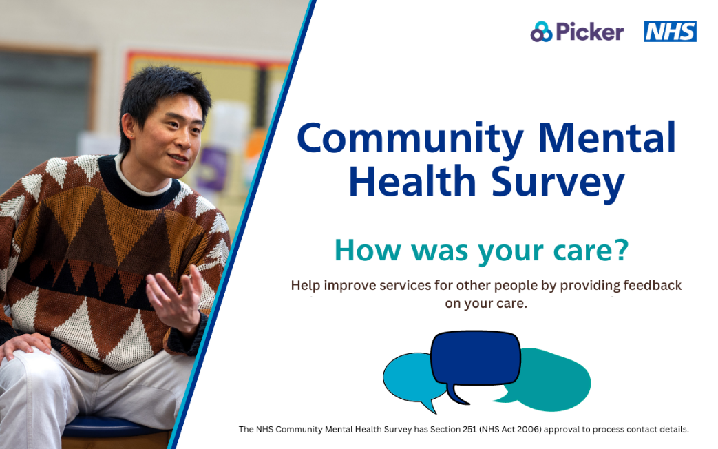

Social media card: Reminder Three
Recently used NHS Community Mental Health services? This is your chance to give feedback on your NHS mental health care.
We are listening closely to what you have to say, your response will help us improve mental health care for you and our community.
#CommunityMentalHealthSurvey
